EC-467 Mobile Application Development

BS (CE)-2021 LAB REPORT #11
Submitted By:

Reg. No. | Name
21-CE-009 | Huzaifa Shahbaz

Department of Computer Engineering
HITEC University Taxila
 | Presentation  (Format(0.5)+  Title (0.5)+  Conclusion(1)  +Procedure(2)  +Objective(1)) | Calculation/ Coding | Observation/  Program Results | Total
Total | 5 | 5 | 5 | 15
Obtained

Lab Instructor.
Dr. Muhammad Bilal

LAB REPORT #11
Android Services
Introduction: A Service is an application component that can perform long-running operations in the background. It does not provide a user interface. Once started, a service might continue running for some time, even after the user switches to another application. Additionally, a component can bind to a service
to interact with it.
For example, a service can handle network transactions, play music, perform file I/O, or interact with a content provider, all from the background.
Tools: Android Studio Jellyfish
Objectives of the experiment: i.To get basic understanding regarding android services. ii.To get basic understanding regarding how to start and stop android services. iii.To get to know about the benefits related to android services.
Class Task JAVA CODE OF Main Activity: package com.huzaifashahbaz.androidserviceapp;
import androidx.appcompat.app.AppCompatActivity;
import android.content.Intent;
import android.os.Bundle;
import android.view.View;
public class MainActivityService extends AppCompatActivity {
Intent serviceIntent;
@Override
protected void onCreate(Bundle savedInstanceState) {
super.onCreate(savedInstanceState);
setContentView(R.layout.activity_main);
}
public void startService(View view){
serviceIntent = new Intent(getApplicationContext(), MyService.class);
startService(serviceIntent);
}
public void stopService(View view){
serviceIntent = new Intent(getApplicationContext(), MyService.class);
stopService(serviceIntent);
}
}
JAVA CODE OF My Service: package com.huzaifashahbaz.androidserviceapp;
import android.app.Service;
import android.content.Intent;
import android.os.IBinder;
import android.util.Log;
import androidx.annotation.Nullable;
public class MyService extends Service {
@Nullable
@Override
public IBinder onBind(Intent intent) {
return null;
}
@Override
public int onStartCommand(Intent intent, int flags, int startId) {
serviceThread thread = new serviceThread(startId);
thread.start();
return START_STICKY;
}
@Override
public void onDestroy() {
super.onDestroy();
Log.d("MyService", "onStartCommand: Service Stopped");
}
class serviceThread extends Thread {
int threadID;
serviceThread(int threadID) {
this.threadID = threadID;
}
@Override
public void run() {
try {
for (int i = 0; i < 10; i++) {
Log.d("MyService", "serviceRunnable Running i = " + i);
Thread.sleep(1000);
}
} catch (Exception e) {
Log.d("MyService", "serviceRunnable Error " + e);
}
stopSelf(threadID);
}
}
}
XML CODE OF Main Activity: <?xml version="1.0" encoding="utf-8"?>
<LinearLayout xmlns:android="http://schemas.android.com/apk/res/android"
xmlns:tools="http://schemas.android.com/tools"
xmlns:app="http://schemas.android.com/apk/res-auto"
android:layout_width="match_parent"
android:layout_height="match_parent"
android:gravity="center"
android:orientation="vertical">
<Button
android:id="@+id/start_service_btn"
android:layout_width="match_parent"
android:layout_height="wrap_content"
android:onClick="startService"
android:text="Start Service"/>
<Button
android:id="@+id/stop_service_btn"
android:layout_width="match_parent"
android:layout_height="wrap_content"
android:onClick="stopService"
android:text="Stop Service"/>
</LinearLayout>

Results:
OUTPUT:
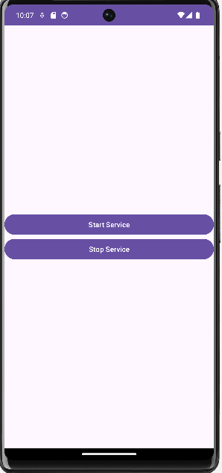
Conclusion: In conclusion, I had learn how to make android services by using Java and xml. And also, I checked its function and working of android services in mobile app.

